Version 1.1

Revision History

|  |  |  |  |
| --- | --- | --- | --- |
| Date | Version | Description | Author |
| 17/Oct/2013 | 1.0 | Initial UC description | Storm Cloud Development |
| 22/Oct/2013 | 1.1 | Updated diagrams  Inserted Cucumber code  Added Mockups | Storm Cloud Development |
|  |  |  |  |
|  |  |  |  |

Table of Contents

1. Use-Case manage calendars 4

1.1 Brief Description 4

1.2 Stored data 4

1.2.1 Overview 4

1.2.2 Description 4

2. Flow of Events 5

2.1 Screen Flow 5

2.2 Use Case Flows 5

2.2.1 Show all contacts (List View) 5

2.2.2 Show single contact (View Single) 6

2.2.3 Create new contact (Create) 7

2.2.4 Edit contact (Edit) 8

2.2.5 Delete contact (Delete) 9

3. Special Requirements 10

4. Preconditions 10

4.1 Rights 10

4.2 Calendar 10

5. Postconditions 10

5.1 Calendar 10

6. Extension Points 10

# Use-Case manage calendars

## Brief Description

The use case manage calendars is a CRUD use case. You can create, read, update and delete a calendars’ metadata. Except for deleting which also deletes all related data like appointments, the changes only affect the calendars metadata.

## Stored data

### Overview

|  |  |  |  |  |
| --- | --- | --- | --- | --- |
| Name | Auto-assigned | Unique | Mandatory | Modifiable |
| Id | Yes | Yes | Yes | No |
| Name | No | Yes | Yes | Yes |
| Description | No | No | Yes | Yes |
| Color | No | No | Yes | Yes |
| Creator | Yes | No | Yes | No |

### Description

The metadata consists of the name of the calendar, a short description and a color for better differentiation when viewing more than one calendar at the same time. Also there is a creator saved, but the creator is automatically set as the user who creates the calendar and it is not possible to change the value later.

# Flow of Events

## Screen Flow

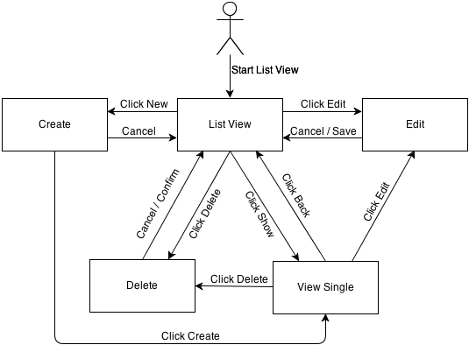

## Use Case Flows

### Show all calendars (List View)

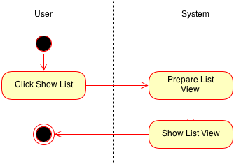

### Show single calendar (View Single)

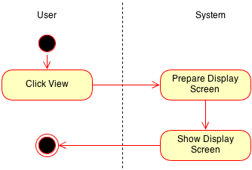

### Create new calendar (Create)

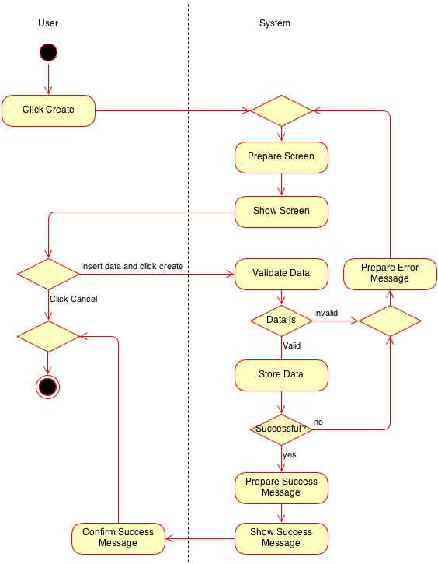

### Edit calendar (Edit)

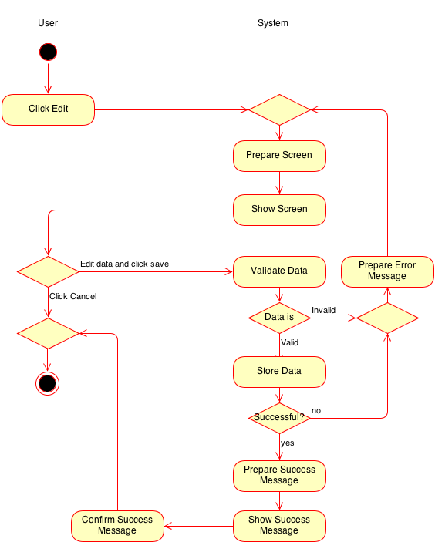

### Delete calendar (Delete)

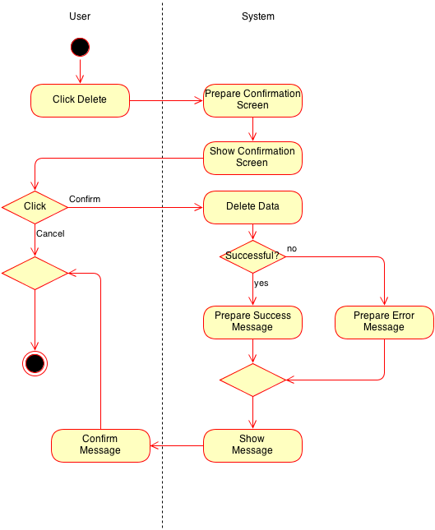

# Special Requirements

n/a

# Preconditions

## Rights

View/edit/delete/create: The user must have the rights to do the operation.

## Calendar

View/edit/delete: The calendar must exist.

Create: The calendar must not exist.

# Postconditions

## Calendar

Edit: The calendar metadata is updated

Delete: The calendar is deleted

Create: The calendar is created

# Extension Points

n/a

# Cucumber test scenario

Feature: manage calendars

As an user

I want to manage calendars

So that I can create and manage my calendars

Scenario: create calendar

Given I am logged in

And I am on the "calendar list"

And I clicked "create calendar"

When I type in the correct calendar data

And I click "create"

Then I should see a confirmation message

Scenario: delete calendar

Given I am logged in

And I am on the "calendar list"

And I clicked "delete calendar"

When I confirm the deletion

Then I should see a confirmation message

# Mockups

## Show all calendars

## Show single calendar

## Create new calendar

## Edit calendar

## Delete calendar